The Mount Rushmore of the Trust Fabric
We’re measuring AI by speed and parameter counts while the real race is for legitimacy. If autonomous agents are going to operate markets, grids, and media, they need more than clever prompts and bigger models. They need a constitutional layer—not a feature, a foundation. Four non-negotiable pillars define it: Attribution, Governance, Provenance, Settlement (AGPS).
Today vs. AGPS. An enterprise agent pulls customer data across three clouds, calls a fine-tuned model from a startup, and triggers a payout. A regulator asks: who accessed what, under which rules, and who got paid? Today’s answer is 30 Slack threads, five PDFs, and a prayer that logs weren’t rotated. With AGPS, the answer is a single receipt chain: signed origins, portable policies, verifiable lineage, and automatic settlement. Boring. Deterministic. Auditable.

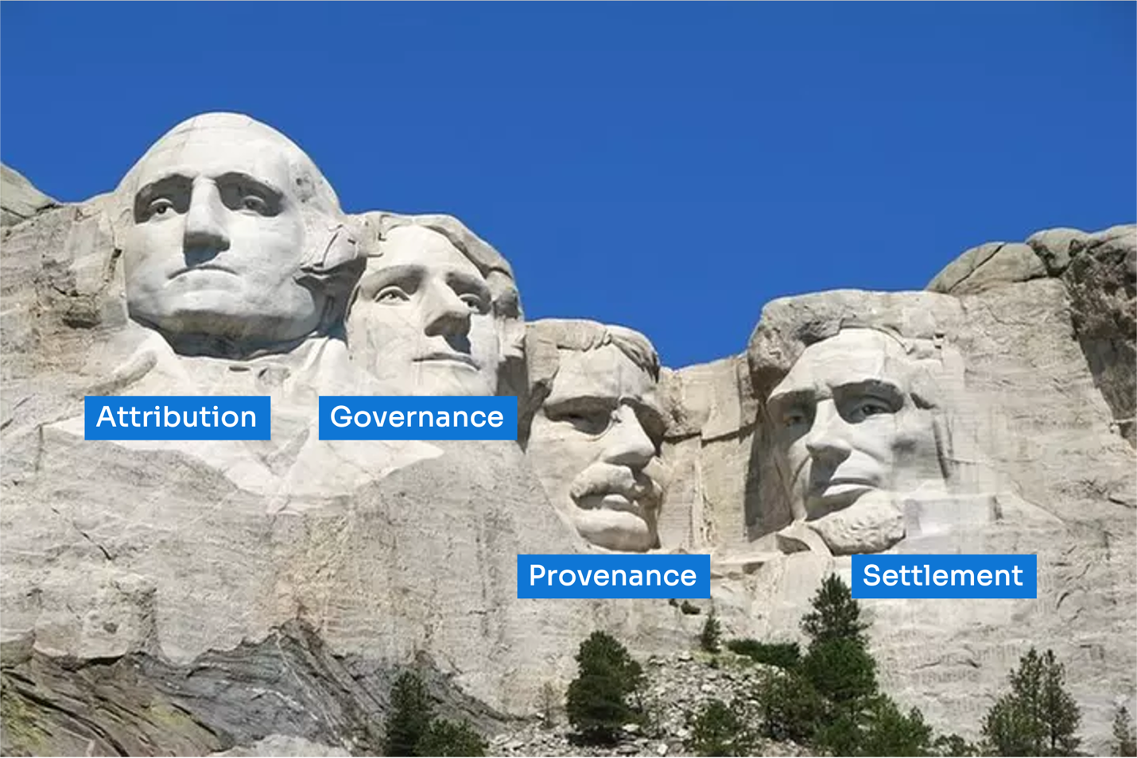

1) Attribution — the property right
Every action, asset, and derivative needs a signed, accountable origin—human or agent. Without attribution, there’s no accountability, no royalties, no recourse.
What good looks like: Every request and output carries verifiable identity; every transformation updates the chain of responsibility.
Why it matters: Creators get paid, operators can be audited, and malicious actors can be excluded.
How it works: durable identity & signatures; beneficiary mapping; tamper-evident lineage; anti-spoof signals tied to real hardware and agents.

2) Governance — the rule of law
Policies shouldn’t live in PDFs. They must travel with the work and be enforced at machine speed—wherever code runs.
What good looks like: Decisions are allowed or denied by enforceable controls, not promises. When rules change (jurisdiction, safety, export), enforcement changes with them.
Why it matters: Paper policies can’t govern API-to-API worlds; enforcement must be technical, portable, and auditable.
How it works: deny-by-default admission; kill-switch & overrides; revocation lists that propagate instantly; jurisdiction-aware routing.

3) Provenance — the chain of custody
In a world of synthetic media and agent swarms, we need evidence, not vibes. Provenance binds what happened to who did it, where, and under which rules.
What good looks like: Every asset and decision carries a verifiable history—sources, transforms, timing, and rationale—recorded as receipts that can’t be quietly rewritten.
Why it matters: You can separate fact from forgery, prove compliance, and settle disputes on the merits.
How it works: lineage graphs; confidence tiers for sources (including energy/carbon evidence); reason codes explaining why decisions were allowed or denied; end-to-end receipt chains.

4) Settlement — the economic engine
If value is created, value should flow automatically to everyone who contributed—at the moment it’s created.
What good looks like: When work completes, the system distributes funds according to agreed shares, with bonuses/penalties tied to provable efficiency and compliance.
Why it matters: Post-hoc billing breaks at agent scale. Real-time economics makes creation sustainable and keeps incentives aligned.
How it works: operator-only efficiency adjustments; escrow for disputes; statutory withholding; fail-closed payouts that never proceed without valid evidence.

Lineage as the interface
The most useful UI in an AI economy is a receipt: a compact, signed record that ties identity, policy, environment, and outcomes together.
- Receipts make governance portable (rules travel with the work).
- Receipts make audits beautifully boring (deterministic, replayable).
- Receipts make payments programmable (evidence → settlement).

Privacy without opacity
You don’t have to choose between proof and secrecy. Use selective disclosure and zero-knowledge attestations so systems prove they complied with policy, honored data residency, measured efficiency, and paid the right people—without revealing sensitive internals (models, routes, beneficiaries, or competitive infrastructure).
Example: A provider proves its energy use met a carbon target and that royalties sum to 100%—without exposing raw telemetry or private commercial terms.

Trust that degrades gracefully
Things go wrong. Trust shouldn’t be binary; it should degrade predictably.
- If measurements disagree, clamp privileges, throttle, or quarantine—and record why.
- If policies expire, mark the event and suppress bonuses rather than guess.
- If keys or devices are revoked, stop work now—not next quarter.
Each outcome is a first-class event with a reason anyone can understand later.

Why this matters now
- Portability: These receipts work across clouds, accelerators, and even disconnected edge, so governance and payments stay consistent wherever agents run.
- Buyers & insurers: The cost of missing evidence is rising (penalties, clawbacks, lost deals). Evidence-first platforms avoid retrofits and win enterprise trust.
- Builders: Ship faster without “just trust us.” Design for proofs, not promises.
Our work at The Bedrock Project is crafting this trust fabric for AI—governable by design—with portable proofs that survive cloud, hardware, and jurisdiction changes.

A small, practical checklist
- Can you name who is acting and who benefits—cryptographically?
- Do policies travel with the work and enforce themselves at runtime?
- Does every decision produce receipts that explain why it was allowed or denied?
- Do payments trigger automatically from that evidence—and halt automatically if evidence is missing?
If you can say “yes” to all four, you’re building on rock, not sand.

Closing thought
AI won’t win by being faster; it will win by being accountable. The leaders will be the teams that can prove identity, prove policy, prove history, and pay who’s owed—automatically. Build on AGPS now and you won’t have to retrofit trust later—you’ll already be there.

LinkedIn version (copy-paste)
The Four Horsemen of the Trust Fabric
We’re fixated on model speed. The real race is for legitimacy. Autonomous agents won’t scale on “trust me.” They need a constitutional layer:
Attribution — every action has a signed, accountable origin.
Governance — policies travel with the work and enforce themselves.
Provenance — decisions and assets carry verifiable history.
Settlement — value auto-routes to every contributor in real time.
Privacy isn’t the enemy of proof. With selective disclosure and zero-knowledge, you can prove compliance, lineage, and payments without exposing sensitive internals. These receipts work across clouds, accelerators, and even disconnected edge, so governance and payouts stay consistent wherever agents run.
If you’re building AI, stop shipping on sand. Design for proofs, not promises—prove identity, prove policy, prove history, and pay who’s owed automatically.
Want a deep dive or example receipts? Comment “trust fabric” or DM me and I’ll share the walkthrough.
PS: The same rail doubles as an Energy AI control plane (per-inference energy/carbon proofs, carbon-aware routing, efficiency-based settlement) and a general trust fabric for non-AI workflows (data pipelines, automation, supply chain).

